THE CLARENCEVILLE SCHOOL DISTRICT
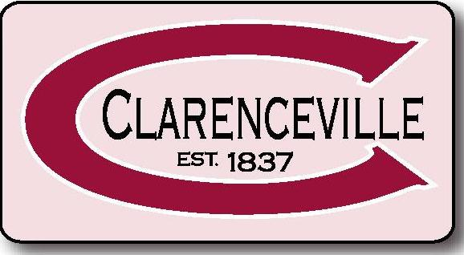
TEACHER/EDUCATOR OF THE YEAR AT THE
HIGH SCHOOL & GRANDVIEW
NOMINATION FORM

The Clarenceville Schools are again participating in a program to honor exemplary teachers. We hope you will join us in an effort that will result in the selection of the TEACHER/EDUCATOR OF THE YEAR for the Clarenceville School District at Grandview and CV high school. This honor will be bestowed at the second Board of Education meeting in April, 2018.

All Nomination Forms must be returned to your school NO LATER THAN January 20, 2018.

WHO IS ELIGIBLE?

Any FULL TIME, CERTIFIED, TENURED teacher/educator who spends 50% of his/her time in a classroom. Nominees must have a minimum of three (3) full years of classroom teaching experience

WHO MAY NOMINATE?

Any person in the community may nominate any teacher/educator in the district for this honor.

HOW TO SUBMIT A NOMINATION FORM

Email submissions to the nominee’s school are preferred. If using a hard copy, please deliver your Nomination Forms to the nominee’s school in an envelope marked clearly with “TEACHER/EDUCATOR OF THE YEAR”.

Please call Renee Valentine (248-919-0252) if you have any questions.

PLEASE USE THE FILLABLE FORM BELOW TO SUBMIT ALL NOMINATIONS.

Form on reverse side.

NOMINATION FORM
DUE: January 20, 2018

CLARENCEVILLE SCHOOL DISTRICT TEACHER/EDUCATOR OF THE YEAR AT THE

ELEMENTARY, MIDDLE SCHOOL AND HIGH SCHOOL LEVELS

Nominee’s Name | School

Please respond in writing to the following questions. You may use the back of this nomination form and additional paper if needed.

- What qualities does this teacher possess that have caused you to nominate him/her for this honor?

- What have you observed about this teacher’s relationships with students, parents, staff and/or community that make him/her worthy of this honor?

- What specific accomplishments do you believe support this teacher’s nomination?

- Are there any honors, memberships or strengths you want to list? Any further comments?

RETURN TO THE NOMINEE’S SCHOOL FOR CONSIDERATION
NO LATER THAN January 20, 2018

